Lab 1 Practices with LMC
(Submit by 3/9/2012/Friday for 120 points in addition to bonus)
(Submit by 4/4/2012/Wednesday for 100 points in addition to bonus)

Your name: | Grade:

Important notice about this lab:
- Provide your answers in a single doc or docx file and submit it at Canvas (at https://salemstate.instructure.com/login):
  - Your Canvas username and password are the same as your SSU/Navigator’s.
  - Your solution for program/LMC code must be in the text format, that is,
    - It must not be a screenshot or image;
    - Each line is only valid LMC instruction (no leading line number).
    - (I’ll copy your code for the testing—if you code is in any other format which prevent me from copying, a zero will be given to that question!)
- On 3/6/Tuesday, we will spend part of lecture hours in the lab for practice of this assignment—but you need to prepare before that time.
- Check the following link for LMC simulator: http://www.atkinson.yorku.ca/~sychen/research/LMC/LMCHome.html
- The following is the LMC Instruction Set (the Mnemonics are little different than those in the handouts given in the class). To use that LMC Simulator, you need to use the following mnemonics.

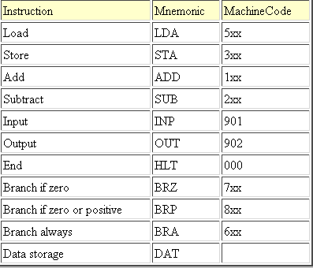

- (25 points)Test the following LMC code segment on LMC simulator and show the result to the instructor and take a screenshot for your submission.

INP
STA FIRST
INP
STA SECOND
SUB FIRST
BRP SECONDBIG
LDA FIRST
OUT
BRA PROGRAMEND
SECONDBIG LDA SECOND
OUT
PROGRAMEND HLT
FIRST DAT
SECOND DAT

- (35 points)The following LMC program (in a different version from the LMC simulator, the program is stored on LMC memory with the starting address of 00) is supposed to add two inputs numbers, subtract a third input number from the sum, and output the result, i.e., Output = n1 + n2 – n3

IN
STO 99
IN
ADD 99
STO 99
IN
SUB 99
OUT
COB

  - Test this program on LMC simulator (you may have to do necessary changes on some instruction code).
  - What is wrong with this program?
  - Modify the program so that it produces the correct result—provide your code in the following space.

- (40 points) Write a LMC program that adds a column of input values and produces the sum as output. The first input value will contain the number of values that follow as input to be added.

- ( Bonus 30 points) Write a LMC program that accepts 3 values as input and outputs them in order of size, largest to smallest.

