Assignment 9
(Due date: 4/26/2012, Thursday, in class)
(Full Score: 150 points)

Your name: | Grade:

1. Convert the following numbers to IEEE single-precision format. Give the results as eight hexadecimal digits.
- 9

- 5/32

- -5/32

2. Convert the following IEEE single-precision floating numbers from hexadecimal to decimal:
- 42E48000H

- 00800000H

- C7F00000H

3. In your own words, describe how affordance and metaphors are used in the User-Interface design. Provide specific examples (by using text description and/or drawing a picture/diagram).

4. List three different paradigms for interaction that are commonly used in the HCI software applications. Provide specific examples.

5. Summarize the distinction between image processing, 2D graphics, and 3D graphics.

6. What are the two steps in producing a “photograph” using 3D graphics?

7. Summarize the three steps in producing an image using 3D graphics.

8. What is the difference between the projection plane and the image window?

9. What is a frame buffer?

10. Why are shapes represented by polygonal meshes even though they could be represented more precisely by geometric equations?

11. What is texture mapping?

12. Summarize the distinction between specular light, diffuse light, and ambient light.

13. Define the term clipping.

14. Explain the distinction between a parallel projection and a perspective projection. You may draw diagrams to clarify your answers.

15. Summarize the distinction between combinational logic circuits and sequential circuits.

16. The following are S-R flip-flop’s block diagram and its internal logic circuit diagram.

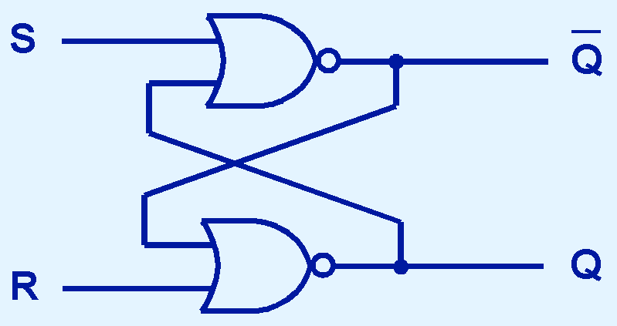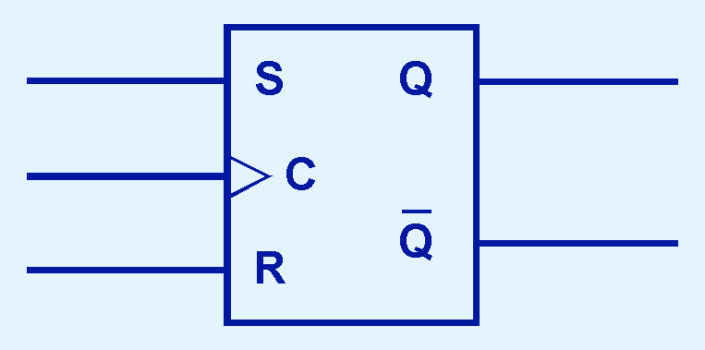

- Draw a truth table that describes the functionality of this flip-flop (the inputs and outputs).
- Explain why there is an input end marked with “C” and how it works with the other inputs “S” and “R”.
- If the inputs for “S” and “R” are 1, what will be the outputs?

17. Draw the block diagram and truth table for D flip-flop.

18. Provide state table and state diagram for the following sequential circuit.

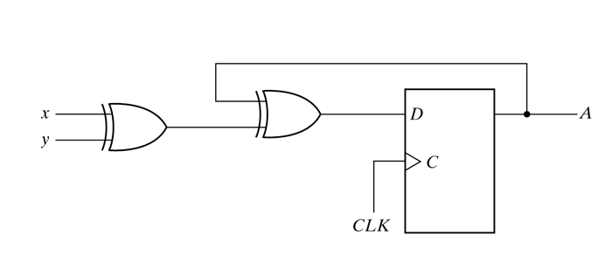

19. The following logic circuit is used to complete a basic logic function. Fill out the Truth Table that describes this circuit. What Boolean operation (of a basic logic function) does the circuit compute?
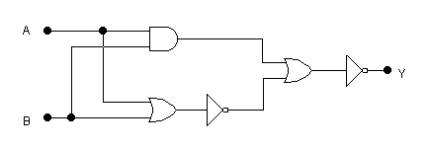
A | B | Y

20. Provide Operational Definition of a Computer.

21. A question about Two Bit Comparator: Fill in the truth table below for output Z which is true when A>B table (A=x₁ x_{2,} B= y₁ y₂ ).

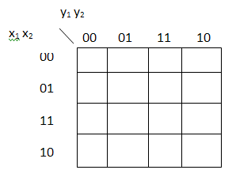

22. Give a definition of distributed system.

23. List at least three reasons for using distributed systems.

24. What is load sharing defined in distributed system.

25. Define the terms data migration and computation migration in distributed systems.

26. What is process migration? List at least three reasons for using process migration in distributed systems.

27. The happened-before relation is denoted by →. Given the following space-time diagram for three processes P, Q, and R.

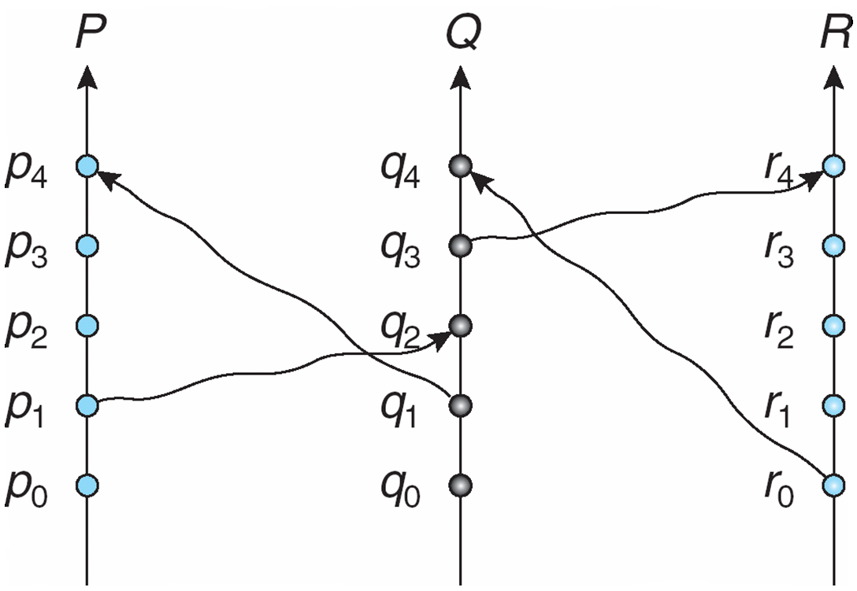

The following are some events related (correctly or incorrectly) by the happened-before relation. Point out which are correct and which are incorrect.

- p1→q2
- q0→p2
- r0→q4
- r0→q3
- q3→r4
- r0→p3
- p1→q4
- q3→p3
- q1→r4
- q1→r3

28. Define the terms Distributed Mutual Exclusion, Atomicity, and Deadlock used in distributed system.

