Assignment 3

(Due date: 6/9/2011, Thursday, in class)

(Full Score: 120 points)

Your name: | Grade:

Important notice on how to submit and grade this assignment:
- How to Grade:
  - The total score for the assignment is 100 points.
  - An extra 8% will be added to the TYPEWRITTEN submissions.
    - Not question text (including the drawing) is required.

The following questions are taken from the textbook Chapter 4 (p. 112-117).
- For questions 18 through 29, using A, B, C, D, E, or F as your answers for each of these.
- Do NOT use any calculators for the conversion/calculation questions.

- For Exercises 1–17, mark the answers true or false (T or F)
1. Logic diagrams and truth tables are equally powerful in expressing the processing of gates and circuits.
2. Boolean expressions are more powerful than logic diagrams inexpressing the processing of gates and circuits.
3. A NOT gate accepts two inputs.
4. The output value of an AND gate is 1 when both inputs are 1.
5. The AND and OR gates produce opposite results for the same input.
6. The output value of an OR gate is 1 when both inputs are 1.
7. The output of an OR gate when one input is 0 and one input is 1 is 0.
8. The output value of an XOR gate is 0 unless both inputs are 1.
9. The NOR gate produces the opposite results of the XOR gate.
10. A gate can be designed to accept more than two inputs.
11. A transistor is made of semiconductor material.
12. Inverting the output of an AND gate is equivalent to inverting the individual signals first, then passing them through an OR gate.
13. The sum of two binary digits (ignoring the carry) is expressed by an AND gate.
14. A full adder takes the carry-in value into account.
15. A multiplexer adds all of the bits on its input lines to produce its output.
16. Integrated circuits are classified by the number of gates contained in them.
17. A CPU is an integrated circuit.
- For Exercises 18–29, match the gate with the description of the operation or the diagram.
A. AND
B. NAND
C. XOR
D. OR
E. NOR
F. NOT
18. Inverts its input.
19. Produces a 1 only if all its inputs are 1 and a 0 otherwise.
20. Produces a 0 only if all its inputs are 0 and a 1 otherwise.
21. Produces a 0 only of its inputs are the same and a 1 otherwise.
22. Produces a 0 if all its inputs are all 1 and a 1 otherwise.
23. Produces a 1 if all its inputs are 0 and a 0 otherwise.
24.
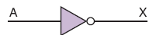

25.
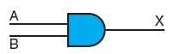
26.
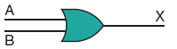

27.
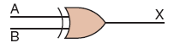

28.
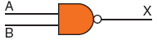

29.
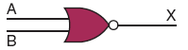

- 30. How is voltage level used to distinguish between binary digits?

- 32. What are the three notational methods for describing the behavior of gates and circuits?

- 34. How many input signals can a gate receive, and how many output signals can a gate produce?

- 37. Give the three representations of an AND gate and say in words what AND means.

- 39. Give the three representations of an XOR gate and say in words what XOR means.

- 43. Give the Boolean expression for a three input AND gate, then show its behavior with a truth table.

- 44. Give the Boolean expression for a three-input OR gate, then show its behavior with a truth table.

- 54. What are the two general categories of circuits and how do they differ?

- 55. Draw a circuit diagram corresponding to the following Boolean expression:
(A + B)(B + C)

- 56. Draw a circuit diagram corresponding to the following Boolean expression:
(AB + C)D

- 57. Draw a circuit diagram corresponding to the following Boolean expression:
A’B + (B+C)’.

- 58. Draw a circuit diagram corresponding to the following Boolean expression:
(AB)’ + (CD)’

- 59. Show the behavior of the following circuit with a truth table:
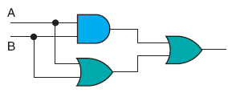

- 60. Show the behavior of the following circuit with a truth table:
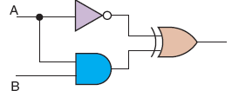

- 61. Show the behavior of the following circuit with a truth table:
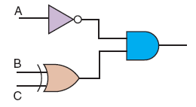

- 65. Differentiate between a half adder and a full adder.

- 69. What is an integrated circuit or chip?

