Assignment 5
(Full Score: 100 points)
(Due in class, Tuesday, 5/3/2011)

Your name: | Score:

Part I: Study Guide Questions
- Go to the course website’s Supplementary Materials where you open Study Guide for Chapter 5 (you will need course web username and password to access it) at http://cs.salemstate.edu/~b_yi/2011Spring/CSC315A/resources/studyGuide/Chapter05_SG.pdf
- Read section “Most Important Ideas and Concepts from Chapter 5” (no submissions required).
- Pay attention to the following Study Guide Q&As:
  - 1, 2, 7, 9,12, 13, 15, 16, and 17.
  - (These Q&A’s will give provide guidance to Part II of this assignment).
  - (No submissions required for this part of assignment.)

Part II: Problems from the Textbook (100 points)
Provide short answers for the following Problems of Chapter 5:

P4. Suppose the information content of a packet is the bit pattern 1110 1011 1001 1101 and an even parity scheme is being used, What would the value of the field containing the parity bits be for the case of a two-dimensional parity scheme? Your answer should be such that a minimum-length checksum field is used.

P5. Consider the 7-bit generator, G= 10011, and suppose that D has the value
1010101010. What is the value of R?

P4. Consider three LANs interconnected by two routers, as shown in the following.
a. Assign IP addresses to all of the interfaces. For Subnet 1 use addresses of the form 192.168.1.xxx; for Subnet 2 uses addresses of the form 192.168.2.xxx; and for Subnet 3 use addresses of the form 192.168.3.xxx.
b. Assign MAC addresses to all of the adapters.
c. Consider sending an IP datagram from Host E to Host B. Suppose all of the ARP tables are up to date. Enumerate all the steps, as done for the single-router example in Section 5.4.2.
d. Repeat (c), now assuming that the ARP table in the sending host is empty (and the other tables are up to date).

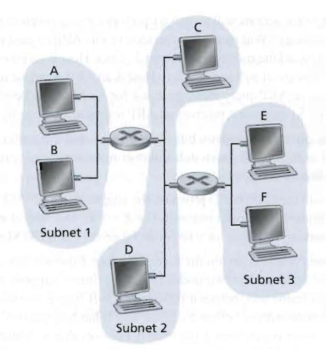

P17. Recall that with the CSMA/CD protocol, the adapter waits K·512 bit times after a collision, where K is drawn randomly. For K = 100, how long does the adapter wait until returning to Step 2 for a 10 Mbps Ethernet? For a 100 Mbps Ethemet?

P18. Suppose nodes A and B are on the same 10 Mbps Ethernet bus, and the propagation delay between the two nodes is 325 bit times. Suppose node A begins transmitting a frame and, before it finishes, node B begins transmitting a frame. Can A finish transmitting before it detects that B has transmitted? Why or why not? If the answer is yes, then A incorrectly believes that its frame was successfully transmitted without a collision. Hint: Suppose at time t =0 bit times, A begins transmitting a frame. In the worst case, A transmits a minimum-sized frame of 512 + 64 bit times. So A would finish transmitting the frame at t =512 + 64 bit times. Thus, the answer is no, if B's signal reaches A before bit time 1= 512 + 64 bits. In the worst case, when does B's signal reach A?

P23. Suppose four nodes, A, B, C, and D, are all connected to a hub via 10Mbps Ethernet cables. The distances between the hub and these four nodes are 300m, 400m, 500m, and 700m, respectively. Recall that the CSMA/CD prolocol is used for this Ethernet. Assume that the signal propagation speed is 2 x10⁸m/sec.
a. What is the minimum required frame length? What is the maximum required frame length?
b. If all frames are 1500 bits long, find the efficiency of this Ethernet.

