Assignment 6
(Due date: 11/17/2011, Thursday, in class)

Your name: | Grade:

Provide very brief answers to the following Artificial Intelligence questions (check Chapter 11 of the textbook (particularly, its section questions/solutions) and lecture slides for solutions—hand-drawing of the tree structures is OK for your typewritten submission):

1. What is agent in the research area of AI? Provide an example.

2. Identify several types of “intelligent” actions that might be made by an agent.

3. What is procedural knowledge? What is declarative knowledge?

4. Briefly describe the components of a Production System.

5. Briefly explain what is heuristic? What are the requirements for good heuristics?

6. We have introduced four different machine learning methods. What are they? Provide a short explanation for each of them.

7. Draw the search tree that is generated by a breadth-first search in an attempt to solve the eight-puzzle from the following start sate without using the assistance of any heuristic information. (hand-drawn diagram is OK).

 | 1 | 3
4 | 2 | 5
7 | 8 | 6

8. Draw the search tree that is generated by a depth-first search in an attempt to solve the eight-puzzle from the following start sate without using the assistance of any heuristic information. (hand-drawn diagram is OK, at most 5 levels of search tree if you cannot get to the goal node).

 | 1 | 3
4 | 2 | 5
7 | 8 | 6

9. Draw the search tree that is generated by the algorithm of Figure11.10 (available from the lecture slides) in an attempt to solve the eight-puzzle from the following start state, assuming the heuristic used is the same as that developed in the textbook. You must mark the heuristic values for the nodes (hand-drawn diagram is OK):

 | 1 | 3
4 | 2 | 5
7 | 8 | 6

10. A question about one of artificial neural network implementation—an associative memory. Consider an artificial neural network shown in the following. Each circle represents a processing unit whose threshold value is recorded inside the circle. The lines connecting circles represent two-way connections between the corresponding units with associate weights. If the network was initialized with its two rightmost units inhibited and the other units excited, what stable configuration(s) does it associate with this initial pattern? Briefly describe the inhibit/excite processes by drawing diagrams and/or writing down the processes (hand-drawn diagram is OK).

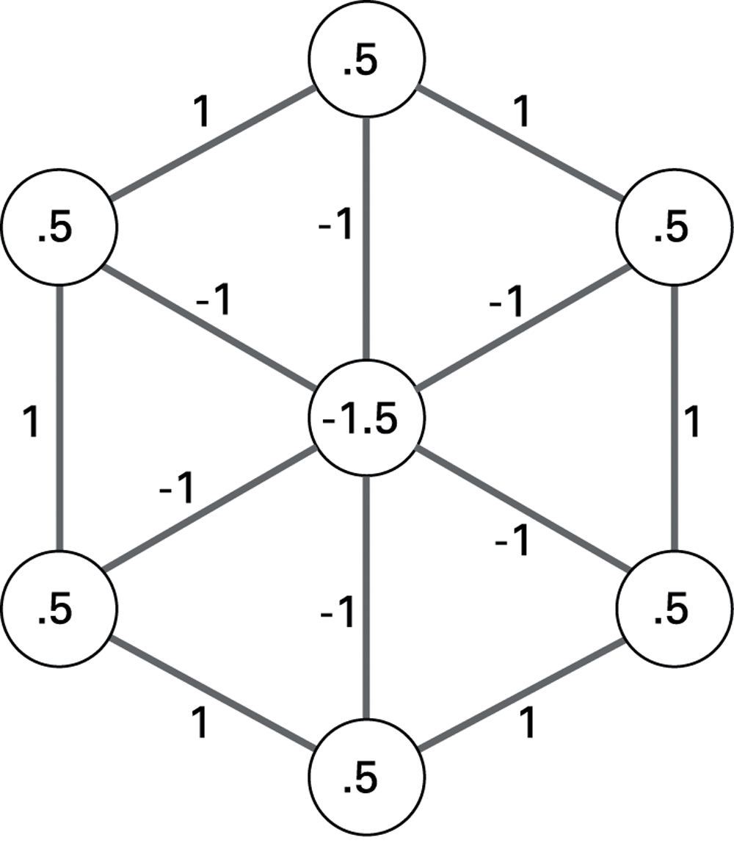

11. Adjust the weights and threshold values in the following artificial neural network so that its output is 1 when both inputs are the same (both 0 or 1) and 0 when the inputs are different (one being 0 while the other is 1).

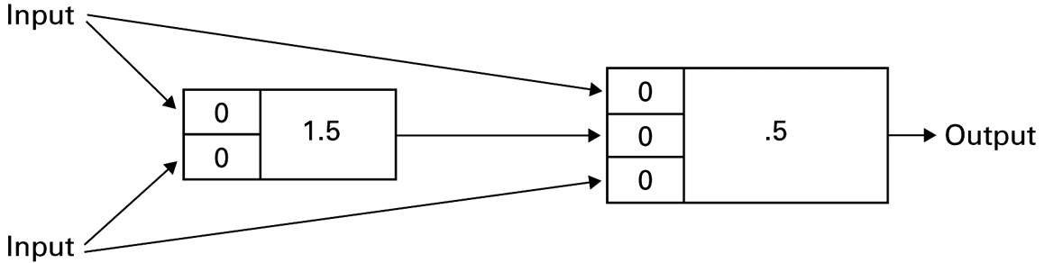

12. Briefly describe how ALVINN works (check the text explanation associated with the following figure):

