Assignment 3
(Due by 10/12/2010/Tuesday, in class)

Your name: | Date:

Provide brief solutions (see the important notes at the end of the assignment) to the following OS questions related to the textbook Chapter 3:

Part One: Provide brief answers to the following Chapter Exercises questions:

4.10 Which of the following components of program state are shared across threads in a multithreaded process?
a. Register values
b. Heap memory
c. Global variables
d. Stack memory

4.12 As described in Section 4.5.2, Linux does not distinguish between processes and threads. Instead, Linux treats both in the same way, allowing a task to be more akin to a process or a thread depending on the set of flags passed to the clone() system call. However, many operating systems—such as Windows XP and Solaris—treat processes and threads differently. Typically, such systems use a notation wherein the data structure for a process contains pointers to the separate threads belonging to the process. Contrast these two approaches for modeling processes and threads within the kernel.

4.14 Consider a multiprocessor system and a multithreaded program written using the many-to-many threading model. Let the number of user-level threads in the program be greater than the number of processors in the system. Discuss the performance implications of the following scenarios.

a. The number of kernel threads allocated to the program is less than the number of processors.
b. The number of kernel threads allocated to the program is equal to the number of processors.
c. The number of kernel threads allocated to the program is greater than the number of processors but less than the number of user-level threads.

5.9 Why is it important for the scheduler to distinguish I/O-bound programs from CPU-bound programs?

5.11 Consider the exponential average formula used to predict the length of the next CPU burst. What are the implications of assigning the following values to the parameters used by the algorithm?
a. α = 0 and τ₀ = 100 milliseconds
b. α = 0.99 and τ₀ = 10 milliseconds

5.12 Consider the following set of processes, with the length of the CPU-burst time given in milliseconds:
Process | Burst Time | Priority
P1 | 10 | 3
P2 | 1 | 1
P3 | 2 | 3
P4 | 1 | 4
P5 | 5 | 2

The processes are assumed to have arrived in the order P1, P2, P3, P4, P5, all at time 0.

a. Draw (Hand drawing OK) four Gantt charts illustrating the execution of these processes using FCFS, SJF, a nonpreemptive priority (a smaller priority number implies a higher priority), and RR (quantum = 1) scheduling.
b. (Using a Table) what is the turnaround time of each process for each of the scheduling algorithms in part a?
c. (Using a Table) what is the waiting time of each process for each of the scheduling algorithms in part a?
d. Which of the schedules in part a results in the minimal average waiting time (over all processes)?

5.13 Which of the following scheduling algorithms could result in starvation?

a. First-come, first-served
b. Shortest job first
c. Round robin
d. Priority

5.15 Consider a system running ten I/O-bound tasks and one CPU-bound task. Assume that the I/O-bound tasks issue an I/O operation once for every millisecond of CPU computing and that each I/O operation takes 10 milliseconds to complete. Also assume that the context switching overhead is 0.1 millisecond and that all processes are long-running tasks. What is the CPU utilization for a round-robin scheduler when:

a. The time quantum is 1 millisecond
b. The time quantum is 10 milliseconds

5.18 Explain the differences in the degree to which the following scheduling algorithms discriminate in favor of short processes:

a. FCFS
b. RR
c. Multilevel feedback queues

5.19 Using the Windows XP scheduling algorithm, what is the numeric priority of a thread for the following scenarios?

a. A thread in the REALTIME PRIORITY CLASS with a relative priority of HIGHEST.
b. A thread in the NORMAL PRIORITY CLASS with a relative priority of NORMAL.
c. A thread in the HIGH PRIORITY CLASS with a relative priority of ABOVE NORMAL.

5.20 Consider the scheduling algorithm in the Solaris operating system for time-sharing threads:

a. What is the time quantum (in milliseconds) for a thread with priority 10? With priority 55?
b. Assume a thread with priority 35 has used its entire time quantum without blocking. What new priority will the scheduler assign this thread?
c. Assume a thread with priority 35 blocks for I/O before its time quantum has expired. What new priority will the scheduler assign this thread?

5.21 The traditional UNIX scheduler enforces an inverse relationship between priority numbers and priorities: The higher the number, the lower the priority. The scheduler recalculates process priorities once per second using the following function:

Priority = (Recent CPU usage / 2) + base

where base = 60 and recent CPU usage refers to a value indicating how often a process has used the CPU since priorities were last recalculated.

Assume that recent CPU usage for process P1 is 40, process P2 is 18, and process P3 is 10. What will be the new priorities for these three processes when priorities are recalculated? Based on this information, does the traditional UNIX scheduler raise or lower the relative priority of a CPU-bound process?

Q599 Read through the programming code related to the following questions (599a, 599b, … through 599i) and fill out the following table based on the outputs (only write down the number (such as 0, 2, 5..) and ignore other string chars (such as “Child: value = ..”).

Question number: | Output at LINE C | Output at LINE P
599a
599b
599c
599d
599e
599f
599g
599h
599a. The program shown in the following uses the Pthreads API. What would be output from the program at LINE C and LINE P?

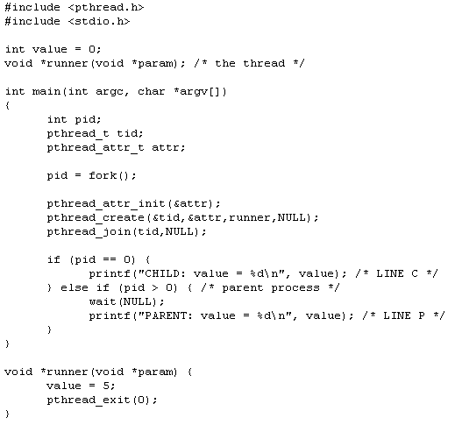

599b. The program shown in the following uses the Pthreads API. What would be output from the program at LINE C and LINE P?

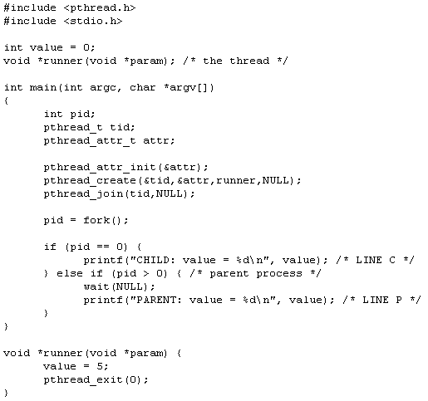

599c. The program shown in the following uses the Pthreads API. What would be output from the program at LINE C and LINE P?

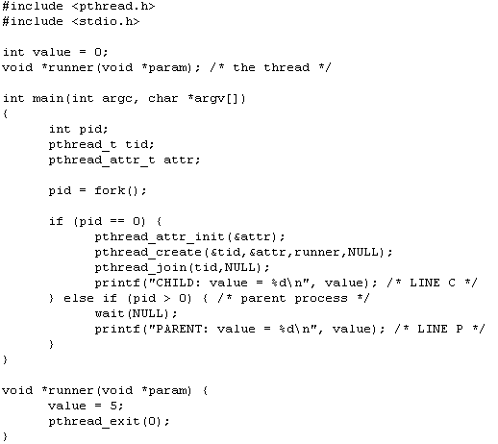

599d. The program shown in the following uses the Pthreads API. What would be output from the program at LINE C and LINE P?

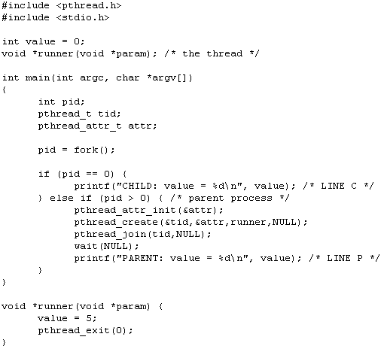

599e. The program shown in the following uses the Pthreads API. What would be output from the program at LINE C and LINE P?

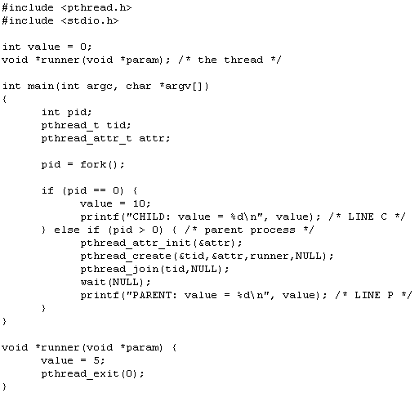

599f. The program shown in the following uses the Pthreads API. What would be output from the program at LINE C and LINE P?

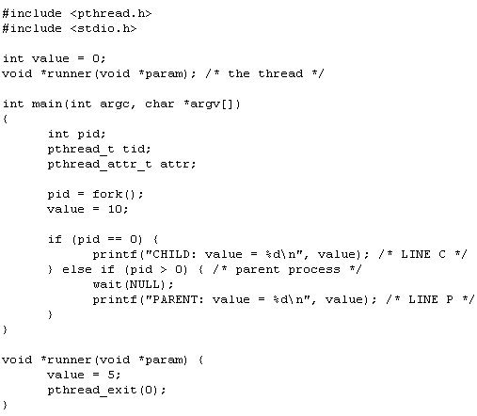

599g. The program shown in the following uses the Pthreads API. What would be output from the program at LINE C and LINE P?

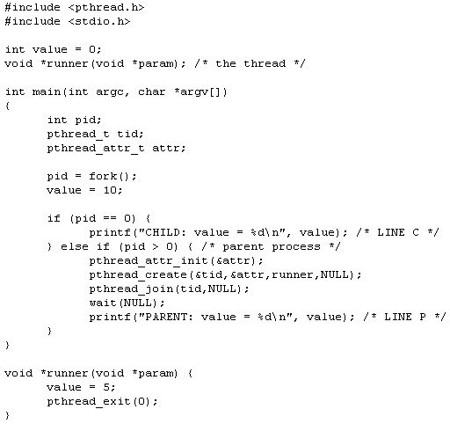

599h. The program shown in the following uses the Pthreads API. What would be output from the program at LINE C and LINE P?

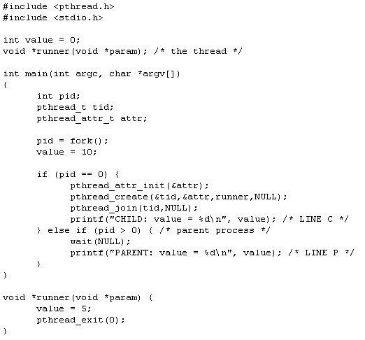

Part Two: Important questions related to Chapters 4 & 5 (No submission):

  - 4.1, 4.2, 4.3, 4.4
  - 5.1, 5.2, 5.3, 5.4, 5.5, 5.6, 5.7
  - (check the course website for these questions and solutions)

========================Important Notes===========================
- Solutions must be typewritten (The question text is not required).
- Have all your solutions in the same order as the above questions.
- Your answers must be succinct and brief: using keywords/phrases is encouraged and no complete sentences are required. For each of the above questions, your answer must be limited within 40 words (with exception of the question 5.12 and Part Two —otherwise, your score for that question will be 0.

