Assignment 3
(Due date: 10/15/2010, Friday, in class)

Your name: | Grade:

Important notice on how to submit and grade this assignment:
- The electronic format of this question sheet is available from the course web.
- You do NOT have to write the question text, but you need to write the question numbers.
- Put your solutions in the same order as the questions appear on the assignment; otherwise, missed or misplaced solutions will NOT be graded.
- How to Grade:
  - The total score for the assignment is 100 points.
  - An extra 5% will be added to the TYPEWRITTEN submissions .
  - 3 points will be deducted from your total score if you missed any ONE of the following (this is a cumulative penalty, e.g., 9 points will be taken for 1 missed name and 2 missed required blank lines):
    - Your name and assignment number on the top of each solution sheet/paper,
    - At least one blank line between solutions of adjacent questions.

1. The steps that the LMC performs are closely related to the way in which the CPU actually executes instructions. Draw a flow chart (like the ones shown in the class) that describes the steps t hat the LMC follows to execute a branch (branch-always) instruction (hand-drawing is considered as “typewritten”).

2. Draw a flow chart that describes the LMC follows to execute a subtract instruction (hand-drawing is considered as “typewritten”).

3. What are the criteria that define a von Neumann architecture?

4. What is the difference between an assembler and a compiler?

5. What is the difference between a declarative statement and an imperative statement?

6. List some common data types and describe how to use them for representing personal information such as ages, height, name…?

7. Identify some common control structures found in imperative and object-oriented programming languages.

8. What is the difference between a global variable and a local variable?

9. What is the difference between a procedure and a function?

10. Draw the parse tree for the expression: x * y + x + z. (* is multiplication operator) (hand-drawing is considered as “typewritten”).

11. What is the difference between an object and a class (hand-drawing is considered as “typewritten”)?

12. Suppose t he classes PartTimeEmployee and FullTimeEmployee inherited the properties of the class Employee. What are some features that you might expect to find in each class?

13. Figure 6.2 (available from slides for the Chapter 6) provides a diagram that describes the evolution of programming paradigms. Put each of the programming languages in that diagram in the following table:

 | Functional | Object-oriented | Imperative | Declarative
1950
1960
1970
1980
1990
2000

14. What is BNF? Explain why and how the following personal mailing address is an example of US-Post-Address BNF defined by the following diagram?

John Smith Jr.
352 Lafayette Street
Salem, MA 01970

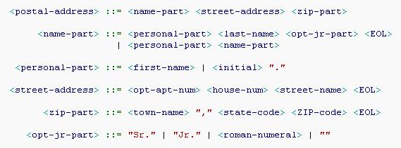

15. What is EBNF? Provide an example about EBNF.

16. Briefly describe the roles of Linker and Loader in the category of system software.

17. The following is a diagram for a 4x3 memory. I₀I₁I₂ are data inputs; A₁A₀ are used for memory address selection; RD is for Read (when RD =1) and Write (when RD =0) control; CS and OE are always 1 (selected); O₀O₁O₂ are output bits (the propagation delays of the logic gates can be ignored because we are testing the circuits in time of seconds or minutes).
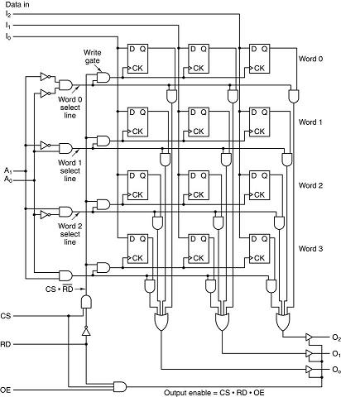

Fill out the following table (if the contents cannot be determined, put “N/A” in the box).

Inputs |  |  |  | Memory/Output
Time | RD | A₁A₀ | I₀I₁I₂ | Word0 | Word1 | Word2 | Word3 | O₀O₁O₂
T₀ | 0 | 00 | 110 |  |  |  | N/A | N/A
T₁ | 0 | 10 | 011
T₂ | 1 | 10 | N/A
T₃ | 0 | 10 | 010
T₄ | 1 | 00 | 101
T₅ | 1 | 10 | N/A

