Assignment 3
(Due date: 10/13/2009, Tuesday, in class)

Your name: | Grade:

Important notice on how to submit and grade this assignment:
- Provide your solutions in the same order as the questions appear on the assignment; otherwise, missed or misplaced solutions will NOT be graded.
- How to Grade:
  - The total score for the assignment is 100 points.
  - An extra 5% will be added to the TYPEWRITTEN submissions.
  - 3 points will be deducted from your total score if you missed any ONE of the following (this is a cumulative penalty, e.g., 9 points will be taken for 1 missed name and 2 missed required blank lines):
    - Your name and assignment number on the top of each solution sheet/paper,
    - At least one blank line between solutions of adjacent questions.

1. The steps that the LMC performs are closely related to the way in which the CPU actually executes instructions. Draw a flow chart (like the ones shown in the class) that describes the steps t hat the LMC follows to execute a branch (branch-always) instruction.

2. Draw a flow chart that describes the LMC follows to execute a subtract instruction.

3. What are the criteria that define a von Neumann architecture?

4. What is the difference between an assembler and a compiler?

5. What is the difference between a declarative statement and an imperative statement?

6. List some common data types and describe how to use them for representing personal information such as ages, height, name…?

7. Identify some common control structures found in imperative and object-oriented programming languages.

8. What is the difference between a global variable and a local variable?

9. What is the difference between a procedure and a function?

10. Draw the parse tree for the expression: x * y + x + z. (* is multiplication operator).

11. What is the difference between an object and a class?

12. Suppose t he classes PartTimeEmployee and FullTimeEmployee inherited the properties of the class Employee. What are some features that you might expect to find in each class?

13. Figure 6.2 (available from slides for the Chapter 6) provides a diagram that describes the evolution of programming paradigms. Put each of the programming languages in that diagram in the following table:

 | Functional | Object-oriented | Imperative | Declarative
1950
1960
1970
1980
1990
2000

14. What is BNF? Explain why and how the following personal mailing address is an example of US-Post-Address BNF defined by the following diagram?

John Smith Jr.
352 Lafayette Street
Salem, MA 01970

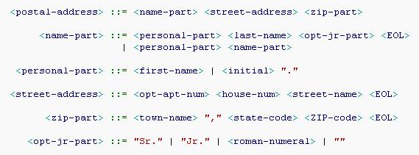

15. What is EBNF? Provide an example about EBNF.

16. Briefly describe the roles of Linker and Loader in the category of system software.

