Project 1a—Adding a System Call to the Linux Kernel
(Due date: 10/3/2008/Friday)

Your name: | Date:

This project is based on the previous project Project#0. If you have not completed the Project#0, you need to (1) successfully complete the Project#0, or (2) work on your own Linux machine (at your own risk such that the this project will change your Linux Kernel and settings, and possible much more time is needed—because the following project steps are strictly based on the Project#0).
- Read the text in the textbook (on pages 93-97) on how to add a system call to the linux kernel.
- I am assuming that you installed Ubuntu8041 (kernel version: 2.6.24-19) appliance and VMware player on your PC as required in Project#0. Otherwise, you might install Ubuntu8041 appliance (if not, you need make some changes to the following steps according to your Ubuntu version).
- Work through the following steps and take screenshots and save them for your submissions.
  - Very important: BE very CAREFULLY when typing the commands and making changes to the (program) files. If there is typo, sometimes, you have to wait for the completion of the Kernel installation to know that you made a mistake, which will take several hours.
- Follow the Submission instructions on how to submit your work for this project.

- Start up the VMware player.
- Boot Ubuntu within the VMware player.
  - I am assuming you have download the Ubuntu8041.
  - The username and password should be “user” for the both.
- Open a CLI/Terminal and type pwd command which will show the place directory of the “user” (at “/home/user”).
  - Get the current Linux kernel version by typing:
    - “date”
    - “uname –r”
    - (I am assuming that it is “2.6.24-19-generic”).
    - Take a screenshot of this CLI (with the outputs of “date” and “uname –r”) for your project submission.
- Type command “sudo passwd root” to update/change root (super-user) password:
  - First you need to provide user’s password (that is, “user”);
  - Then type the new-password for root (REMEMBER this root password);
  - Retype this new password again.
- Log in as root by typing “su” command (you need to provide the root password for command prompt question). Now you are root user that can write anything to the system’s directories.
- Update your Linux package database type:
  - apt-get update
- Install all needed packages by typing the command:
  - apt-get install kernel-package libncurses5-dev fakeroot wget bzip2
  - When you are asked if you continue [Y/n]?
    - Type “Y”—upper case!!
  - Wait for sure these packages have been updated successfully.
- Enter directory “/usr/src” by typing command:
  - cd /usr/src
  - (make sure you are under this directory by using command “pwd”).
- Download new kernel with the following command:
  - wget http://www.kernel.org/pub/linux/kernel/v2.6/linux-2.6.25.3.tar.bz2
  - If the above command does not work, do the following:
    - Use Firefox to download the above kernel
    - It will be (usually) saved on the “Desktop”
    - Copy that file to your current directory which is “/usr/src” (if not you need to enter there by “cd /usr/src”):
      - “cp /home/user/Desktop/linux-2.6.25.3.tar.bz2 .” (do NOT forget the “.”)
- Extract the file and prepare for compiling by using the following commands:
  - “tar xjf linux-2.6.25.3.tar.bz2”
  - “ln -s linux-2.6.25.3 linux”
  - “cd linux”
- Add a System Call to the Kernel:
  - Go to directory “/usr/src/linux/kernel” by using “cd …” command
  - Open and Edit the file “workqueue.c”:
    - Type command “gedit workqueue.c” to open the file;
    - Insert the following among the “#include….” at the beginning of that file:
#include <linux/linkage.h>
    - Insert the following to the end of the file:

asmlinkage int sys_helloworld() {
printk(KERN_EMERG "hello world!");

return 826;
}

- Define a new system call number for __NR_helloworld in “unistd_32.h”:
  - “gedit /usr/src/linux/include/asm-x86/unistd_32.h”
  - Assign a unique number to __NR_helloworld, as shown in the following (here, the unique number for it is 327):

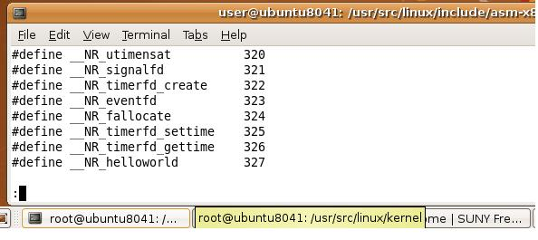

- Add an entry “.long sys_helloworld” to the “syscall_table_32.S”:
  - “gedit /usr/src/linux/arch/x86/kernel/syscall_table_32.S”;
  - Add the entry as shown in the following:
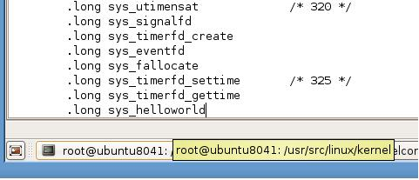

- Configure the kernel (now you are in the directory “/usr/src/linux”) through the following commands:
  - “cp /boot/config-`uname -r` ./.config”
    - Do NOT forget the two “.”
    - The “`” key is at the upper-left corner of the keyboard!!!
  - “make menuconfig”, which will display the kernel configuration menu:

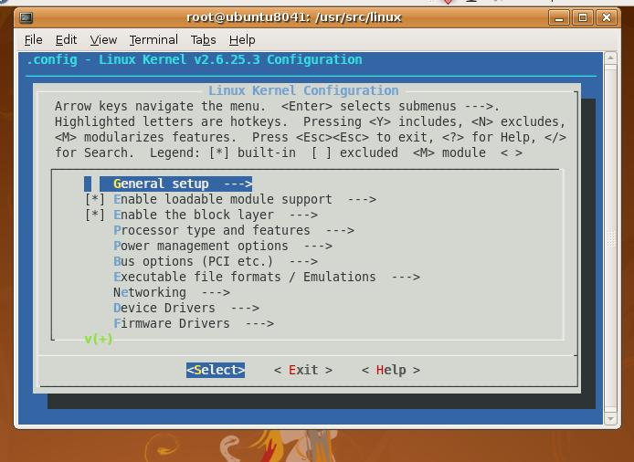

  - Using the arrow keys to go to Load an Alternate Configuration File as shown in the following:
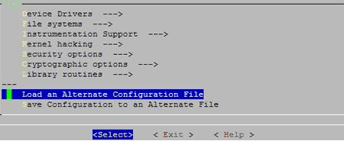

  - Choose (or input) the “.config” file:

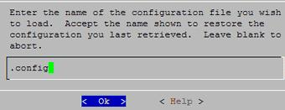

  - After selecting the above .config file, you may go through the kernel configuration (if you don’t know about them, do NOT make any changes!).
  - Now you can exit by pressing <ESC><ESC> or selecting Exit.
  - Answer the following question with YES:

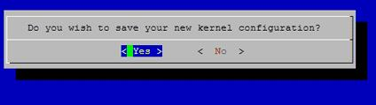

  - On you CLI, there will be messages saying that configurations have been written to .config. Otherwise, you need to start the above process.

- Build the new kernel:
  - “make-kpkg clean”
  - “fakeroot make-kpkg --initrd --append-to-version=-beifang kernel_image kernel_headers”
    - In the above command, after “—append-to-version=”, you can add any string that helps you identify the new kernel (you must begin with a minus (-)! Here is “-beifang”).
      - You need to use your firstname (NO upper case) for this new version string (I used “Beifang”)
    - Be PATIENT: while in the compiling process which will take several hours (2-4 hours) depending on your machine.
    - Examine the outputs (when finished) for any possible exit/errors.
- Install the new kernel:
  - “cd /usr/src”;
  - “ls –l”—The following will be displayed on the CLI:

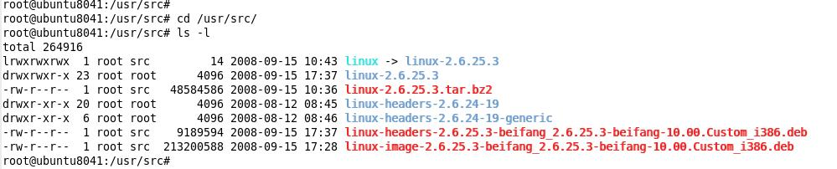

  - There are two files ended with “.deb” with new version script “..beifang…”. Now install them:
    - “dpkg -i linux-image-2.6.25.3-beifang_2.6.25.3-beifang-10.00.Custom_i386.deb”
    - “dpkg -i linux-headers-2.6.25.3-beifang_2.6.25.3-beifang-10.00.Custom_i386.deb”
    - (Important: if you provided different Version Text, you need to use yours!)
  - Reboot the system by using:
    - “shutdown -r now”
    - Provide the username and password when asked.
  - Now you have the new kernel installed/updated on your machine. Check the new version:
    - “date”
    - “uname –r” and you will get something like the following:

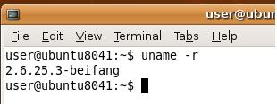

    - Take a screenshot of this CLI with the outputs of “date” and “uname –r” for your project submission.

- “make-kpkg clean” to clean the *.o files.
- Test the newly inserted system call in the updated Linux kernel:
  - Remember: we have updated/installed the new Linux kernel but we have not renewed the system’s “include” files (*.h) in their corresponding directories. Thus, when we test the new system call function, we have to use those *.h under the “/usr/src/linux.” A makefile is needed to tell the compile where to find them. To make things simple, we will take a shortcut illustrated in the following steps.
  - If you are not a root user, type “su” to become a superuser.
  - Edit the system’s syscall.h file by typing :
    - “gedit /usr/include/bits/syscall.h”
    - Insert “#define SYS_helloworld 327” to that file as shown in the following picture (I assume that the unique number you used in step 12 is 327).

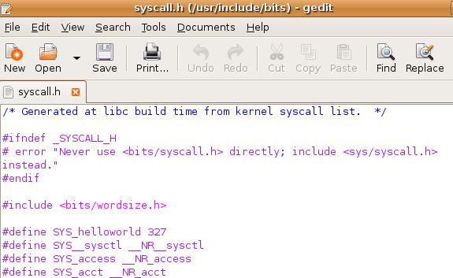

  - Create a test c program (see the following, with the name of “testNewKernel.c”):

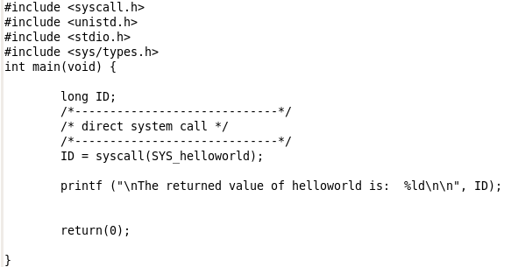

  - Compile this c program with “cc testNewKernel.c”
  - Run the executable file a.out with “./a.out” and you will get the results like the following:
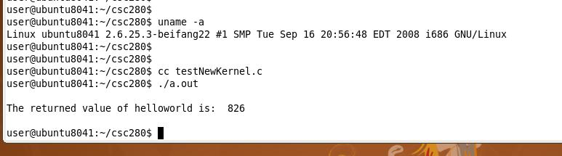

  - As you can see, the new system call has been successfully called and it returned the value we defined in the system call code!
  - Take screenshot (similar to the above one, i.e., including the outputs of “uname –a”, “cc testNewKernel.c”, and “./a.out” for your submission.

How to submit:
- One group (one or two people in a group) is required to submit one copy by email by the due date.
- All your work should be included in ONLY one SINGLE Word or PDF file, which includes:
  - A cover page with group’s name, project title,…
  - Screenshots taken in the Project Steps 3, 16, and 18.
    - You need to take these shots in this order as you work through the project.
- Bring a hardcopy to class on the due day or the class days in the following week—your hardcopy should the printout of your email submission. If the email and hardcopy submissions are different, I will grade them separately and use the lower grade for you project grade.
- Penalty will be applied if your submission does not follow the above instructions.

