Assignment 7
(Deadline: 12/14/2008/Sunday Midnight by email)
(No extension! Submitted by the deadline: 100%; After the deadline, 0%)

Your name: | Date:

1. What protection problems may arise if a shared stack is used for parameter passing (14.5).

2. If all the access rights to an object are deleted, the object can no longer be accessed. At this point, the object should also be deleted, and the space it occupies should be returned to the system. Suggest an efficient implementation of this scheme (14.8).

3. What are the main differences between capability lists and access lists (14.1)?

4. Capability lists are usually kept within the address space of the user. How does the system ensure that the user cannot modify the contents of the list (14.10)?

5. What are the goals and the guiding principle of protection in the Operating Systems (ch14-slides)?

6. What is Access Matrix? Give an example to show how it works (ch14-slides)?

7. A password may become known to other users in a variety of ways. Is there a simple method for detecting that such an event has occurred? Explain your answer.

8. The list of all passwords is kept within the operating system. Thus, if a user manages to read this list, password protection is no longer provided. Suggest a scheme that will avoid this problem. (Hint: Use different internal and external representations.)

9. What is the difference between threat and attack (ch15 slides).

10. Briefly explain the following program threats (ch15 slides):

- Trojan horse
- Trap door
- Logic bomb
- Stack and buffer overflow.

11. Briefly describe how public-key encryption works (ch15 slides).

12. What is digital certificate? Briefly describe how it works (ch15 slides).

13. What is SSL? Briefly explain how it works (ch15 slides).

14. Discuss the advantages and disadvantages of caching name translations for computers located in remote domains (16.4).

15. To build a robust distributed system, you must know what kinds of failures can occur. List three possible types of failure in a distributed system (16.8a).

16. What are data migration and computation migration (16 slides).

17. What is process migration? List at least 3 reasons why we use process migration (16 slides).

18. Briefly explain the terms fixed routing, virtual circuit, and dynamic routing (16 slides).

19. What are location transparency and location independence (ch17 slides).

20. What are distinctions between stateful and stateless services in failure recovery (ch17 slides).

21. The happened-before relation is denoted by →. Given the following space-time diagram for three processes P, Q, and R (ch18).

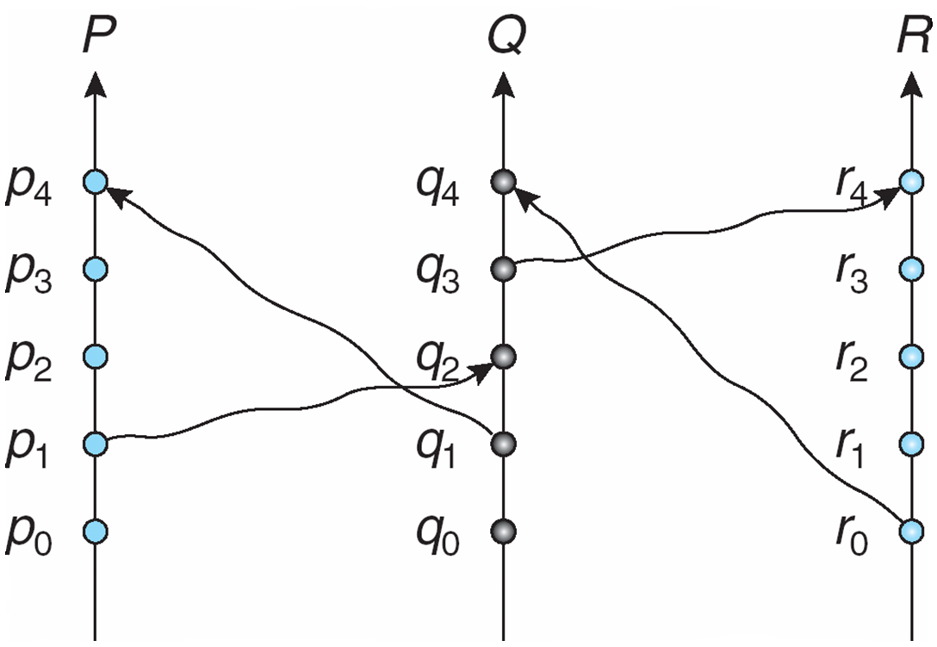

The following are some events related (correctly or not incorrectly) by the happened-before relation. Point out which are correct and which are incorrect.
- p1→q2
- q0→p2
- r0→q4
- r0→q3
- q3→r4
- r0→p3
- p1→q4
- q3→p3
- q1→r4
- q1→r3

22. Define the terms Atomicity, and Deadlock used in distributed system (ch18).

23. Briefly describe one of the distributed mutual exclusion (DME) algorithms: fully distributed approach (ch18 slides).

24. Briefly describe the failure handling algorithm in 2PC (need to consider the two different failures) (ch18 slides).

25. Briefly describe the three main performance evaluation metrics in evaluating Operating Systems.

26. Briefly describe the three main performance evaluation techniques/methods in evaluating Operating Systems.

